W311M,W311MI,W311MA-How to configure the AP mode for the wireless adapter

Product line: wireless question catogory: internet setup

Notes：
1. The wireless adapter have the function as ap, but in order to use this function, you need to install the driver with Tenda WLAN utility.
2. You need to make sure that you can access to internet with your loca area connection

Steps are as follows:
1. Please right click the UI icon on the taskbar of your desktop and select “Switch to AP Mode”.
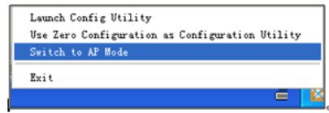
2. When sucessfully switch to ap mode, the following page will pop up
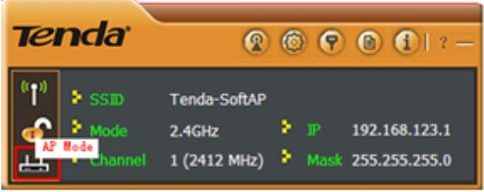

3. Click AP config to configure the AP
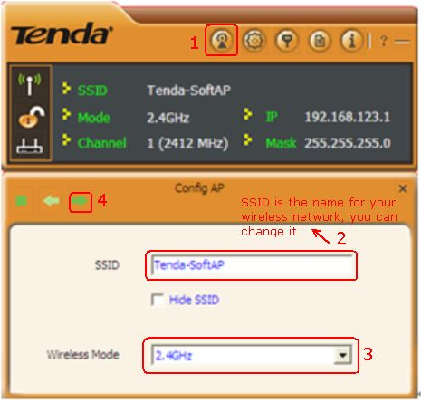
4. Select the channel for your AP then click NEXT to select the encrytion type for your AP, you can choose open and not use to share your wireless network without password or choose WPA-PSK and AES to set a password for your wireless network
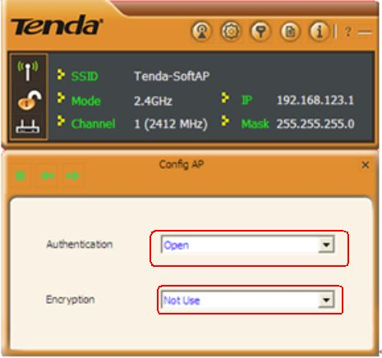
5. Now you have finish your settings, you can try to use other wireless device to connect to the signal of your AP and go to internet.

